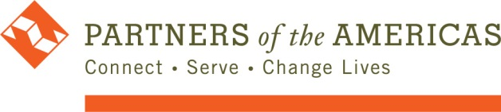

Approval Checklist SubAgreements and Subcontracts

SubAgreement and Subcontract Approval Checklist

Subcontract:  DUNS Number (if applicable) | Number of the SubAgreemnt or Subcontract (attached): | Value of award:
 | No. Of Sub Modifications | Agreement or Contract Terms:
Prime Contractor: POA | Agreement Number (POA): | Contracting Officer (CO):
Contracting Officer Representative (COR): | COR Approval or Authorization: Yes No | Date:

- Copy of the Subagreement or Subcontract is included? Yes No

- POA verified all the provisions required in the original agreement are included the Subagreement or Subcontract:
Acquisition: Yes No

Assistance: Yes No See BDO Matrix

- POA verified that the Subcontractor is not in the de SAM/ World Compliance list as ineligible? Yes No

- POA verified that the Subcontractor is not a non-US Government or Foreign Government parastatal? Yes No

- POA has the justification for why the Subcontractor was selected? Yes No

- POA has taken responsibility for selecting this Subcontractor? Yes No

- POA has verified that the Subcontract/Subagreement does not include any changes in the description of the program or in the approved budget for the contractor? Yes No

- POA has verified that the contract does not include expenses related to: construction, medicine, vehicles, agricultural products or other goods or materials that are restricted? Yes No

- This development activity is justifiable in the program description? Yes No

- The contractor has properly and reasonably translated the technical requirements of the sub-contract/agreement? Yes No

- POA has studied in detail the budget allocations with the contractor and demonstrated what program costs are fair and reasonable. Additionally, POA emphasized that all expenditures incurred must follow the regulations of the donor. Yes No

- POA has obtained a competitive bid or in case where a competitive bid is not possible, there is Judaification for the sole bid through a memo? Yes No

Comments:

